

**Year 12 Integrated Science 2020**

**Task 1: Extended Response - Wetlands in Western Australia**

**Background Information**

Wetlands are vital for human survival. They are among the world’s most productive environments; cradles of biological diversity that provide the water and productivity upon which countless species of plants and animals depend for survival.

Wetlands are indispensable for the countless benefits or “ecosystem services” that they provide humanity, ranging from freshwater supply, food and building materials, and biodiversity, to flood control, groundwater recharge, and climate change mitigation.

Yet study after study demonstrates that wetland area and quality continue to decline in most regions of the world. As a result, the ecosystem services that wetlands provide to people are compromised.

Western Australia’s unique and diverse wetlands are rich in ecological and cultural values and form an integral part of the natural environment of the state.

**Task**

You are tasked with completing a research assignment on a significant wetland from Western Australia. The assignment involves:

* a set of research notes (see below for specifics)
* A 5 min presentation (powerpoint, video, poster, other) that outlines the key information from your research.

You need to choose one of the following wetlands (no more than 2 students can do each wetland).

* Becher Point Wetland
* Forrestdale and Thomson lakes
* Lake Gore
* Muir-Byenup System
* Ord River floodplain
* Roebuck Bay
* Lake Toolibin
* Vasse-Wonnerup System
* Peel-Yalgorup System
* Lake Warden
* Lake Argyle and Kununurra

**Key Dates**

Research Notes: Mon 10th – Thurs 13th Feb (3 lessons)

In-class presentation: Thurs 20th Feb 2020

**Task Weighting**

15% of the year mark.

**Total marks available**

60 marks

**Part 1: Research Notes [39 marks]**

You are required to research the answers for the following questions.

Your notes need to be:

* Written in your own words. ANY SECTIONS THAT ARE PLAGIARISED WILL NOT BE MARKED.
* Concise, using dot points where applicable.
* Correctly referenced (in-text and bibliography).

Your research notes **WILL** need to be submitted to your teacher at the beginning of the lesson of the final presentation.

**Useful resources**

<https://www.dpaw.wa.gov.au/management/wetlands>

<https://www.environment.gov.au/water/wetlands/ramsar/criteria-identifying-wetlands>

<https://www.environment.gov.au/water/wetlands/australian-wetlands-database/australian-ramsar-wetlands>

**Part 2: Presentation [21 marks]**

With the information you have collected through your research, produce a 5-minute presentation that will engage the viewer (your fellow peers). Your presentation must include all key information from your research. You can choose any presentation type you think applicable to present this information.

|  |  |  |  |
| --- | --- | --- | --- |
| **Description** | **3 marks** | **2 marks** | **1 mark** |
| Presentation of content   * PowerPoint * Video * Online website * Poster | 8-10 slides/sections included with key ideas linked to images and sources of information referenced. | **8-10 slides/sections included that shows organisation of ideas in each of the researched content areas.** | 7 slides/sections included that is mainly text. |
| Content | Shows a full understanding of the topic | Shows a good understanding of the topic | **Shows some understanding of the topic** |
| Use of headings and sub-headings | All headings and subheadings used. | **Some headings and subheadings used.** | Some headings used |
| Delivery | Speaks with fluctuation in volume and inflection to emphasize key points. | **Speaks with satisfactory variation of volume and inflection.** | Speaks in uneven volume with little or no inflection. |
| Creativity | Creative use of fonts, transitions or animation function that includes a short-embedded clip/s that have been produced by the student | Some attempt to use transitions or animation functions on PowerPoint. | **Some relevant images used and an attempt made to use colour, smart art or different fonts.** |
| Audience interest | Engaging and interesting all the way through. | Captured interest reasonably well. | **Relevant information is included.** |
| Engagement | High level of effort. | **Satisfactory level of effort.** | Little effort shown. |
| **Total** | **11/21** | | |

**Marking Guide**

|  |  |  |
| --- | --- | --- |
|  | **Item Description** | **Marks** |
| Research Notes | 1. *Wetland description*   Clearly define what constitutes a wetland  Outline the different types of wetlands and what makes them important. | **1**/2 |
| 1. *Ramsar Convention*   Correctly define what the Ramsar Convention is and clarify why is it important? | **1**/2 |
| 1. *Justification*   Identify which Ramsar Criteria your WA wetland qualifies for.  Clearly explain using multiple points how your WA wetlands meets this Ramsar Criteria. | **2**/4 |
| 1. *Map*   Provide a map of your WA wetland site (include geographical coordinates and location of nearest town or major town/city).  Ensure that you clearly delineate the various types of wetlands within your site. | **1**/4 |
| 1. *Key Features*   Analyse and describe the key features of your WA wetland site (biogeography, physical conditions, hydrological values, wetland type). | **2**/8 |
| 1. *Fishbone*   Use the Fishbone Template to classify noteworthy biotic factors (flora and fauna) that inhabit your WA wetland.  For each, describe what makes each one noteworthy. | **0**/6 |
| 1. *Social/Cultural Values*   Describe if the site has any social and/ or cultural values and detail what makes them important. | **0**/4 |
| 1. *Ecological Condition of your WA wetland*   Analyse how current land and water use activities within the Ramsar site and surrounding catchment are affecting the ecological character of your WA wetland. | **0**/6 |
| 1. *Referencing*   Include in-text referencing and provide a bibliography. | **0**/3 |
| **Research Notes Sub Total** | | **7/39** |
| Presentation | Presentation of content | **2**/3 |
| Content in presentation | **1**/3 |
| Use of headings | **2**/3 |
| Delivery | **2**/3 |
| Creativity | **1**/3 |
| Audience interest | **1**/3 |
| Engagement | **2**/3 |
| **Presentation Sub Total** | | **11/21** |
| **TOTAL** | | **18/60**  **30%** |

**Part 1: Research Notes**

1. Wetland description (Define what constitutes a wetland and describe the different types of wetlands and what makes them important). **1** (2 marks)

Wetlands are areas that are either waterlogged or overflown with water. The 4 types of Wetland are: Permanently Inundated, Seasonally Inundated, Intermittent Inundation, and Seasonally Waterlogged. Wetlands sustain an overwhelming amount of Flora and Fauna species

1. Describe what the Ramsar Convention is and clarify why it is important. **1** (2 marks)

The Ramsar Convention is a treaty between nations that acts to preserve and protect Wetlands. It is important as Wetlands sustain significant numbers of Flora and Fauna, and they need to be protected

1. Identify which Ramsar Criteria your WA wetland qualifies for. 1, 5, 6 **(1 mark)**

Clearly explain using multiple points how your WA wetlands meets this Ramsar Criteria. **2** (3 marks)

1: Lake Warden is a prime example of Saline Coastal Lakes

5: <30000 waterbirds have been observed at Lake Warden

6: Lake Warden supports over 1% of Hooded Plovers. This species breeds often at this site.

1. Provide a map of your WA wetland site (include geographical coordinates and location of nearest town or major town/city). Ensure that you clearly delineate the various types of wetlands within your site.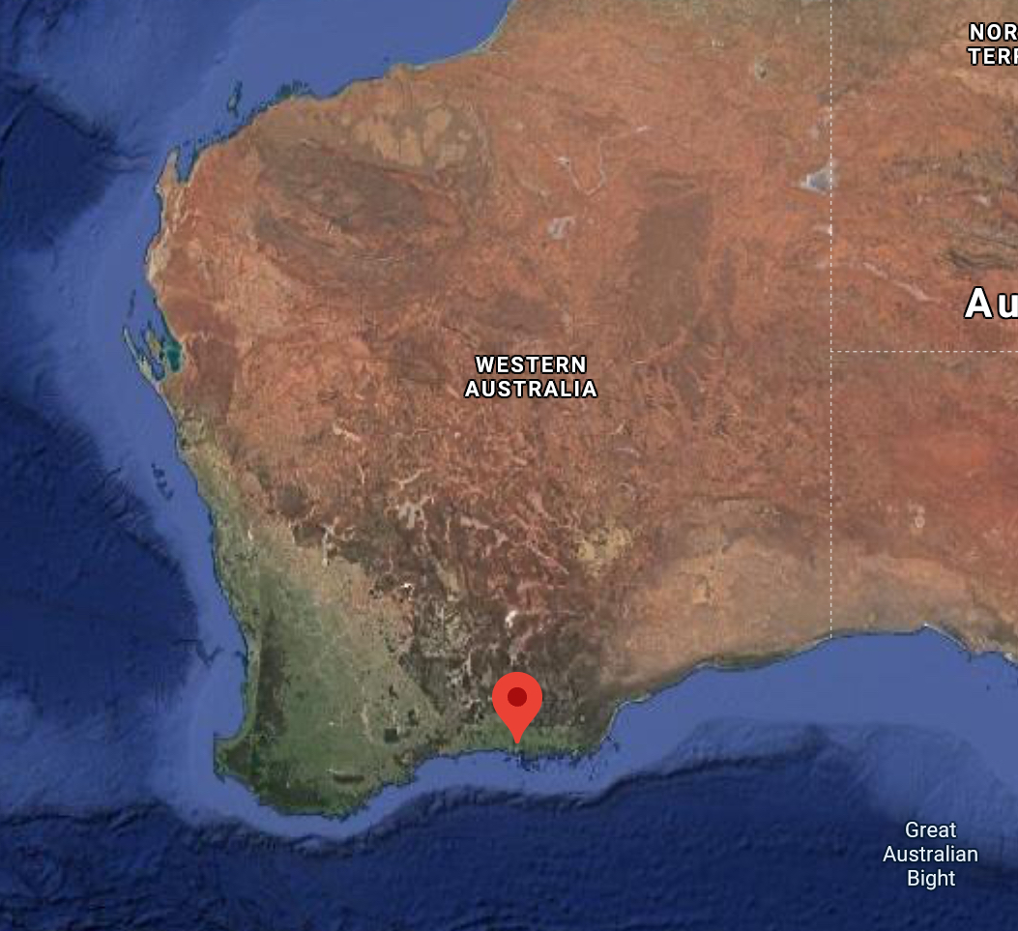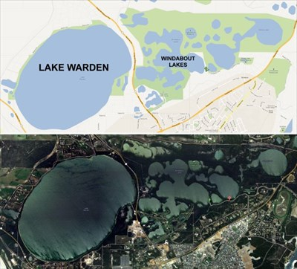

**1** (4 marks)

1. Analyse and describe the key features of your WA wetland site, include the following: biogeography, physical conditions (including climate data), hydrological values, wetland type. **2** (8 marks)

-Located next to Esperance (South Coast)

-Water enters through groundwater and surface run off

-

1. Use the Fishbone Template to classify noteworthy biotic factors (flora and fauna) that inhabit your WA wetland. For each, describe what makes each one noteworthy. **0** (6 marks)
2. Describe if the site has any social and/ or cultural values and detail what makes them important.

**0** (4 marks)

N/A

1. Analyse how current land and water use activities within your site and the surrounding catchment are affecting the ecological character of your WA wetland. **0** (6 marks)
2. Bibliography (Referencing) **0** (3 marks)

